MTH 200 | Newton’s Method

Directions: Solve all problems on a separate sheet(s) of paper. Place your name on the pages you submit. You must show all of your work to receive full credit on problems. You must write complete sentences when asked to show/prove something or provide an explanation/justification. You are encouraged to work with others, consult sources, use calculators, etc. However, only submit solutions that you fully understand. Do not submit solutions which are copied from a friend or another source.

Challenge Questions

Newton’s Method
- Indicate on the graph where the first two interactions of Newton’s method will lie if one starts with the indicated value a. Then explain why a would or would not be a good starting point to approximate the root of the function.
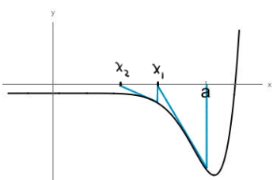

- Newton’s method doesn’t always work. For example, consider the function .
- What is the only root of this function?
- Pick any value between -1 and 1 (other than 0) for your starting guess to find the only root to this function. Calculate the first 10 approximations generated by Newton’s method for the root.
- Let’s look at Newton’s Formula more closely here. Consider the general formula for and attempt to simplify it fully. How does this explain what we saw in part (b)?

- The ancient Babylonians used the formula to calculate . One would start by making a guess for the square root of a and come up with an improved estimate . This process was repeated until the desired accuracy was obtained.
- Derive the Babylonia formula for by applying Newton’s method to find the root of the equation .
- Use the Babylonian formula (equivalently, Newton’s method) to calculate to three decimal places.
- Try to explain how the Babylonians might have come up with this formula without the benefit to calculus, derivatives, and Newton’s method. Hint: Think about how the quantities and compare with when is an overestimate and when is an underestimate of .

- Consider the equation (where a represents some real number).
- Apply newton’s method to the equation to derive the following algorithm for computing reciprocals:
(This is one way a computer can find reciprocals without actually dividing.)

We will create a function and attempt to find for what value of x this function equals 0.
We calculate that .

Using Newton’s method we know that

- Use this algorithm to compute correct to six decimal places.

We know that and will be a root of if . Therefore, to create our approximations of we will use the formula

We make our initial guess based on the fact that . So, we guess that .

Therefore, we calculate

